Add-in Password Keeper

General purpose
The aim of this IE add-in is providing an integrated password manager.

Technical choices
This add-in is coded in C# and store data in a SQL Server database.
This project uses the « Addin Express » tool which let programming in .NET. Indeed, initially IE add-ins have to be developed in C++ language.

User passwords are hashed with Argon 2 algorithm.
Entries data are ciphered with AES algorithm.

Functional presentation

Login
This is the connexion screen

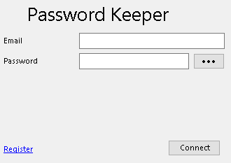

The user has to fill the email and password field to log in.

Remark: The form can be submitted by pressing enter key when the password field is focused.

Registration

If the user click on the register link, the connexion screen changes to become the registration screen

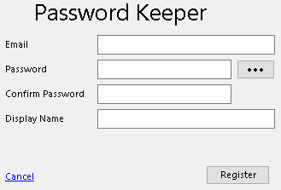

The registration screen is used to create a new user. All fields are mandatory.
- The email field is unique in database, so this information is only used for one account (one email → one account).
- The password field is the field where the main password will be defined. Be careful and take care to choose a secure password because this is the master password.
- The confirm password field is used to control the user doesn’t make a mistake when he typed his password.
- The display name field is used to show a friendlier name than the user’s email. The user is free to choose anything.

Main screen

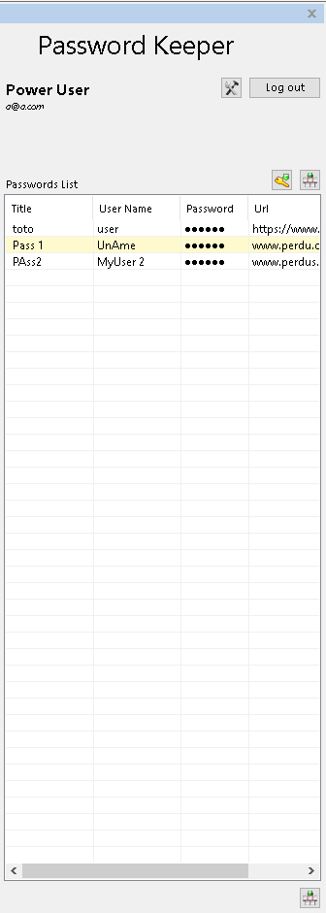
This screen provides a general information on the connected user (display name and email) and lists the entries created.

The user edit button is used to modify user’s password and display name.
The log out button disconnect the current user and return on the connection screen.

The main grid lists all user’s entries. The autocomplete button fills the login and password fields of the website form with the selected entry login and password.

The new entry button displays a form to create a new entry.

User management
The connected user can modify his password and display name by clicking on the edit button

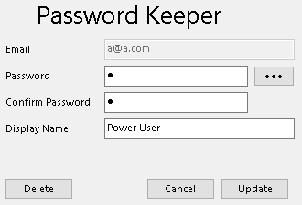

The email field is read only. The email is the first information of a user account and can’t be modified.
The other fields are the same usage than the registration mode.

The cancel button cancels the modifications and back to the main screen.
The update button updates the account with the new values.
The Delete button erases the current user account.

Remark: a manual recovery is possible in case of wrong deletion. To do it and for safety reasons, the value (Boolean) of the IsActive column must be set again to true (1) directly in SQL (table User).

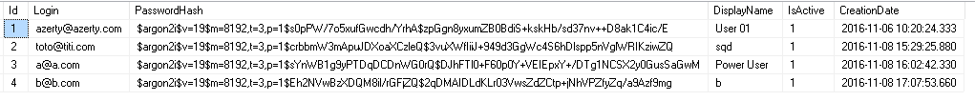

Add entry

The user can add a new entry by clicking on the new entry button
A new window is opened.
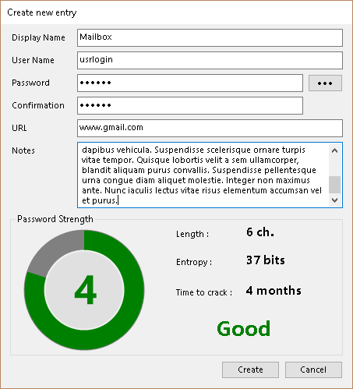

- Display name field will display the entry’s name in the main table.
- User name field is the login used for the website.
- Password field is the password used for the website.
- Confirmation field is used to verify the password. Both of them must match.
The user can show the password and the confirmation fields by clicking on the hide/show password button
- URL field is the URL for the website/login page.
- Notes field let the user to add some useful comments about the entry or the website for example.

The Password strength section inform the user about the chosen password complexity, length, strength. It helps him to avoid to create a too weak password.

Create button store the newly created entry in database and cancel button close the window without saving.

Update Entry

Every entry can be edited by:
- Double clicking on the title column of the main list.
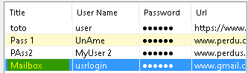

- Right clicking anywhere on the entry’s row of the main list and choosing edit entry
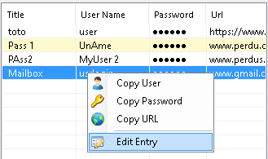

The same window as new entry is opened with the information of the selected entry.

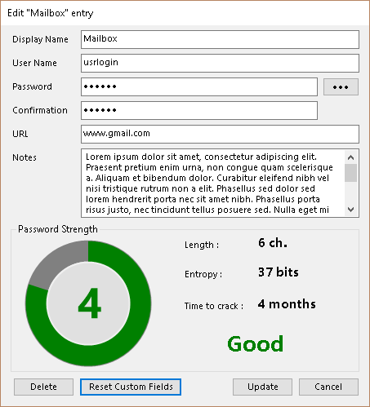

All the rules and constraints are similar as the new entry mode.

Delete button deletes the current entry.
Reset custom fields deletes the custom autotype configuration.

Main list behaviour

The user can copy into clipboard login, password and interact with URL field following 2 ways:
- Double clicking on the login or password column of the involved entry.
Double clicking on the URL column will open a new tab and go to the selected URL.
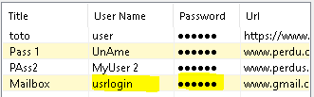

- Right clicking anywhere on the entry’s row of the main list and choosing copy user or copy password. With this method, the user can also copy the URL by choosing copy URL.

Once a data is copied into the clipboard, a timer is started and the clipboard is automatically cleared after 15s for security purpose. A countdown bar is shown and decrease during 15s.

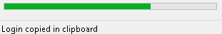

Auto complete

Auto complete operation can be performed by clicking on the buttons. The add-in will try to fill the login and password fields of the current website page.
If this process fails (most of time due to non-standard control names), the user can assign manually the login and password fields. To achieve this task, the user has to right click on the user/password field of the page and chose the correct context menu (set login or set password).
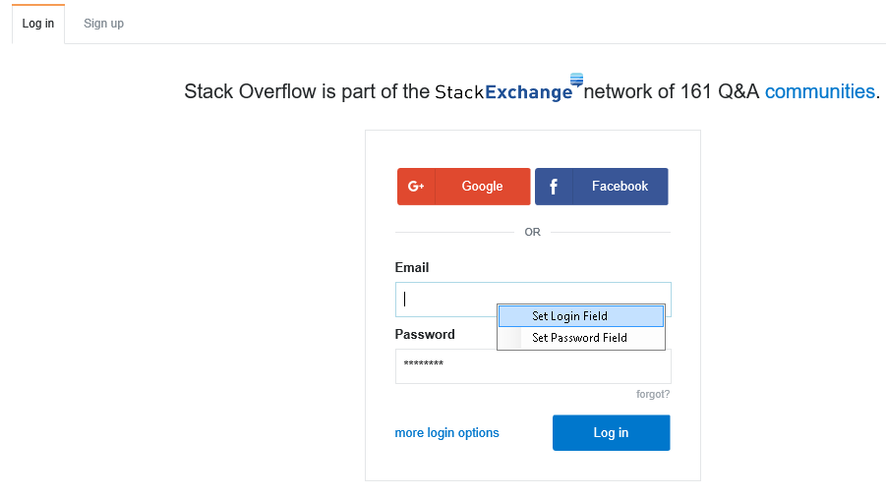

The control ID of the selected field will be stored in database and mapped with the kind of data (login or password).

Once this operation is done, the user just has to click on the auto complete button to use the custom configuration.

